
THE UNIVERSITY OF AZAD JAMMU & KASHMIR
M U Z A F F A R A B A D

LAB REPORT — 01
Installation of
XAMPP Software

SUBMITTED BY | Syeda Khadija Hassan
ROLL NO | 2024-SE-09
COURSE | Database Systems
COURSE CODE | CS-2204
SUBMITTED TO | Engr. Awais Rathore
DATE | 4th Mar, 2026

DEPARTMENT OF SOFTWARE ENGINEERING

Installation of XAMPP Software
Database Systems · CS-2204 · Lab 01
Step 1: Downloading the Installer:
The process began by searching for “XAMPP download” on Google. The official website, Apache Friends (apachefriends.org), was selected to ensure a secure and authentic download of the software.
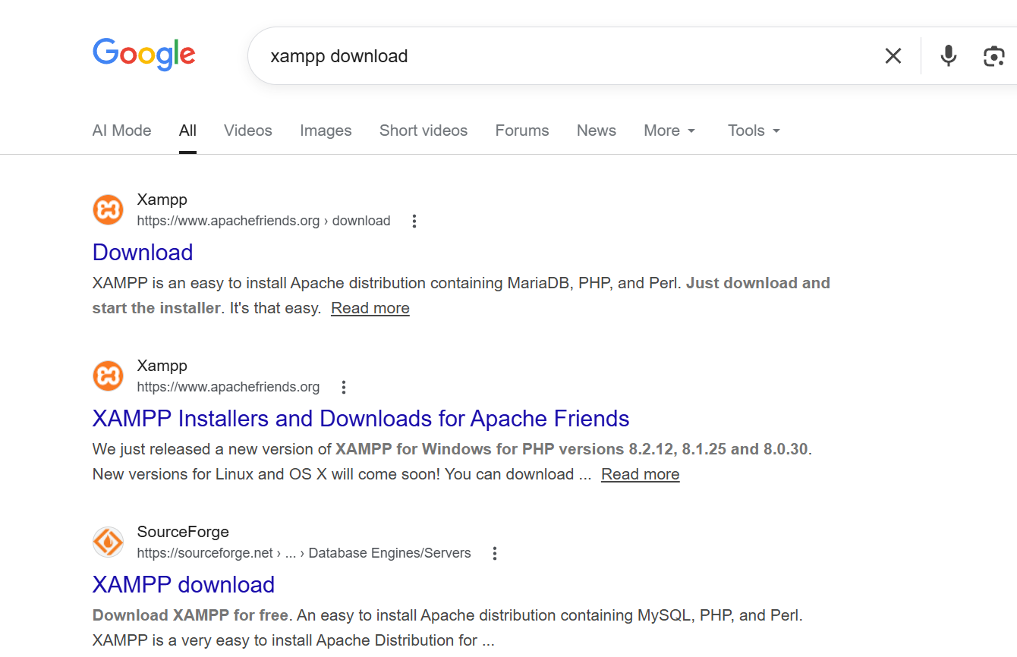
Step 2: Version Selection:
On the official download page, the version compatible with Windows was selected. For this lab, a version supporting PHP 8.x was chosen to ensure compatibility with modern web development standards.
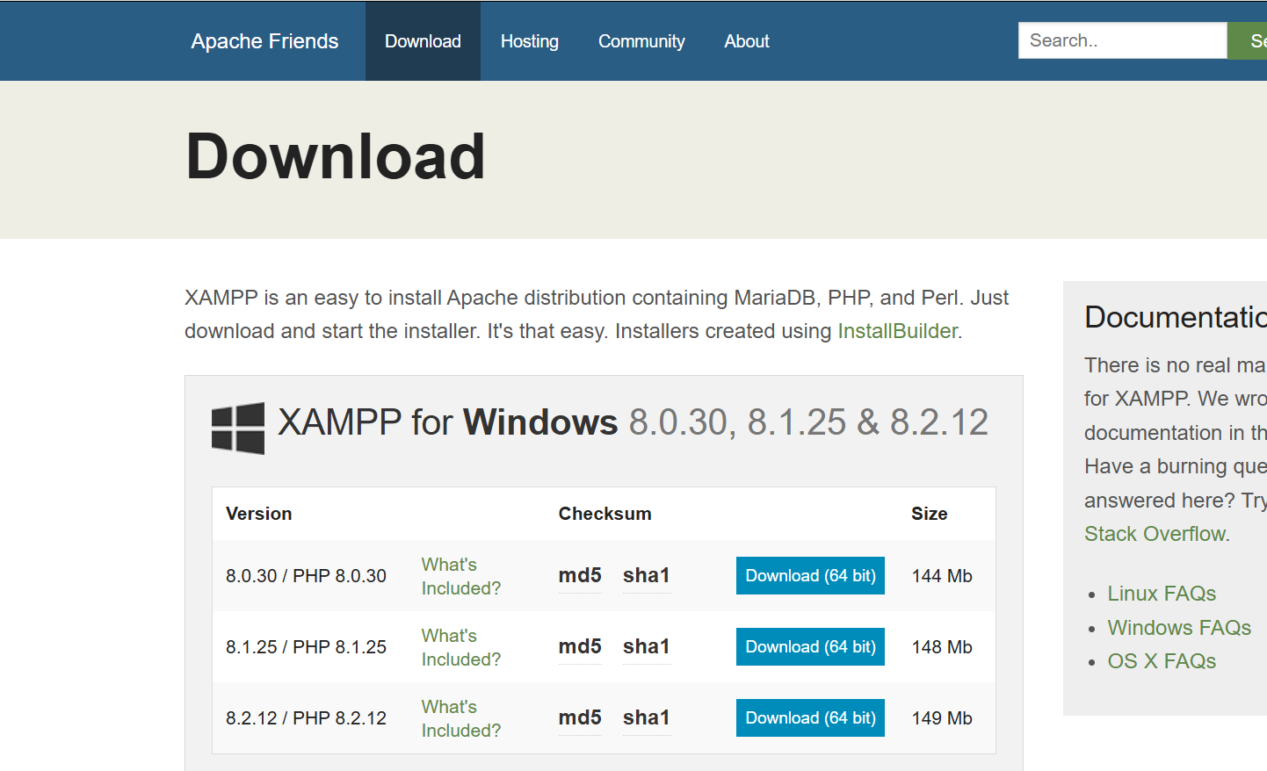
Step 3: Launching the Setup Wizard:
After the executable file (.exe) was downloaded, it was launched as an administrator. The XAMPP Setup Wizard appeared on the screen, providing a guided interface to begin the installation.
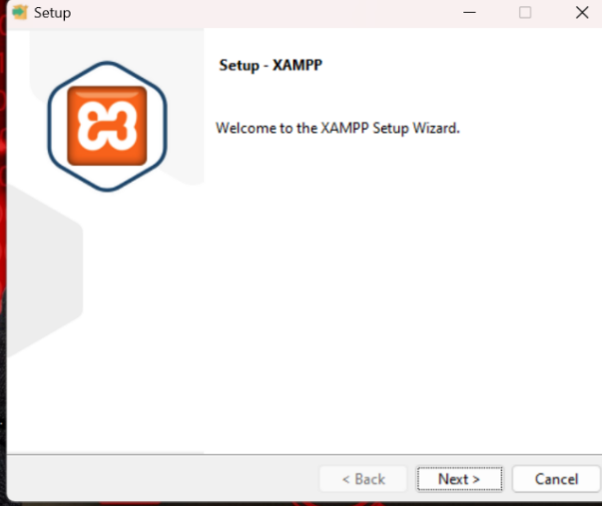
Step 4: Selecting Software Components:
During this stage, specific components were selected for installation. Essential services like Apache (Web Server), MySQL (Database), and phpMyAdmin (Database Management Tool) were checked to ensure a complete local development environment.
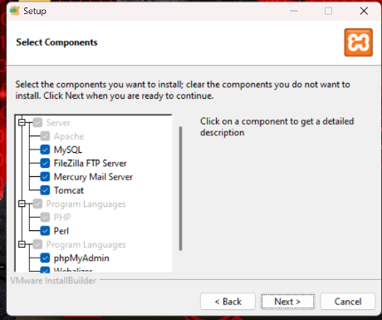
Step 5: Choosing Installation Folder:
The installation directory was set to the default path: C:\xampp. Using the default path is recommended to avoid potential permission issues within the Windows “Program Files” directory.
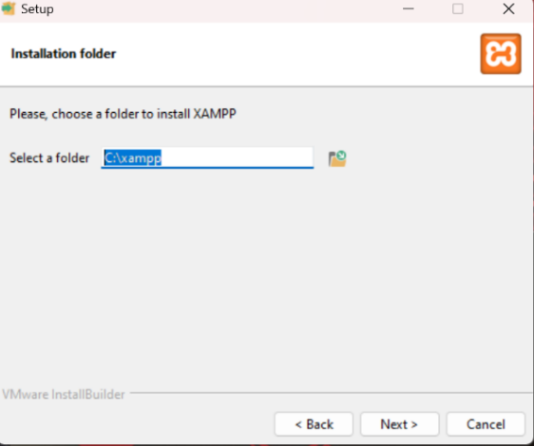
Step 6: XAMPP Control Panel Initialization:
Once the installation was finished, the XAMPP Control Panel (v3.3.0) was opened. This panel serves as the central hub to start, stop, and configure the various server modules.
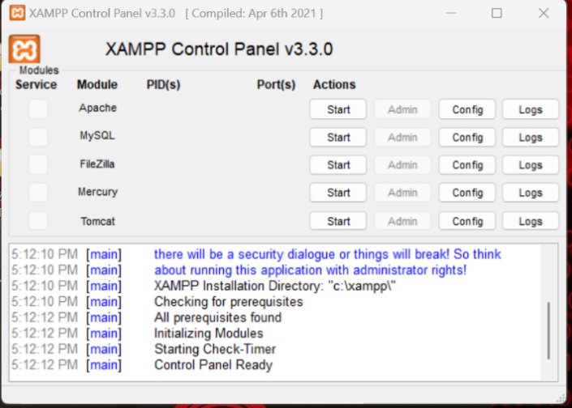
Step 7: Final Verification and Testing:
To verify that the local server was functioning correctly, the browser was directed to http://localhost/phpmyadmin. The successful loading of the phpMyAdmin dashboard confirms that the Apache server and MySQL database are installed and communicating properly.
